3103 Final Project – Artificial Intelligence Option
rev. 2026-January Nemeroff
Name: Medha Bhatnagar
Project Selected: AI Project News Categorization with Classical ML and Deep Learning
---

Introduction
Briefly introduce your project. What motivated you to select this topic, and what do you hope to explore?
You may choose a topic from Modules 6 and 7 (Digital Security, Privacy, Cloud Computing), connect it to your major/area of study, or pursue a creative project of your design.
Creative Examples:
- One student with a statistics background created a predictive model for NBA games, combining vibe coding with their own statistical expertise to evaluate the model's predictions.
- Another student built an image interpreter using Teachable Machine to identify specific cuisines by analyzing images of dishes from around the world.
- A previous student collaborated with ChatGPT to brainstorm EDM music ideas and then built out a track in their mixing software.
Important: Pick projects where you have expertise to bring to the table. Students who attempt approaches outside their knowledge area often struggle to properly evaluate outputs and act as an effective human in the loop. Make sure if you choose this option, you really know what you're doing in your chosen domain.
Common Project Types: Students typically select from machine learning models using Google Teachable Machine (vision/audio/movement detection), LLM-based projects, or DIY approaches that combine multiple tools and techniques.
✍️ I chose this topic because I enjoy applying machine learning algorithms to data, not only does it help me understand the data better, but also how data science can be used to make decisions in real world applications. Specifically, I will be exploring how good both classical and deep learning machine learning models are at classifying news data. This work is quite important to the process of searching, content recommendation, and media monitoring within mainly news corporations, but also other companies. I hope to gain a deeper understanding of the process of cleaning data, doing EDA, using the ml models, and being able to cross-validate.
---

Problem
Clearly describe the problem, question, or idea your project addresses. What do you hope to learn, demonstrate, or solve by applying AI tools and techniques?
✍️ It will address the problem of classifying news articles, with the choice of the four following categories: World, Sports, Business, or Science/Technology. This NLP task is fundamental to search engines, recommendation systems, and content organization. The question I hope to answer is Does increased model complexity lead to better performance in classification compared to simpler, classical ml models for short, topically structured text?
In this process, I want to practice applying EDA on datasets, ml models to data, and cross validation for model performance analysis.
---

Skills Applied
Apply at least 10 total skills drawn from course concepts and your project design. These can be foundational or advanced. See the Appendix for ideas.
Core Required Skills: You must demonstrate your ability to evaluate AI outputs critically and question how the AI arrived at its conclusions. Even if outputs appear correct, they could still be incorrect. You need to engage with this process actively and document your evaluation approach.
Note: you can tag this section under both Base and Additional Skills.
✍️
- Evaluate and critique AI outputs for accuracy, reliability, and correctness.
Model accuracy using weighted F1 scores, Train time, and accuracy scores. I used four models, Logistic Regression(classical ml model used for typically binary prediction), BiLSTM(neural network that process sequences of data both forewords and backwards), Random Forest(classical ml model that builds decision trees and combines their outputs), and Transformer(deep learning model designed to process sequences of text). Here were the following Accuracy scores, F1 scores, and times:
Logistic Regression (Accuracy: 92.11%, F1: .921, Time: 3.5s), BiLSTM(Accuracy: 91.72%, F1: .917, Time: 4,129s), Transformer(Accuracy: 91.18%, F1: .912 ,Time: 11,828s), Random Forest(Accuracy: 89.38%, F1: .893, Time: 193 s).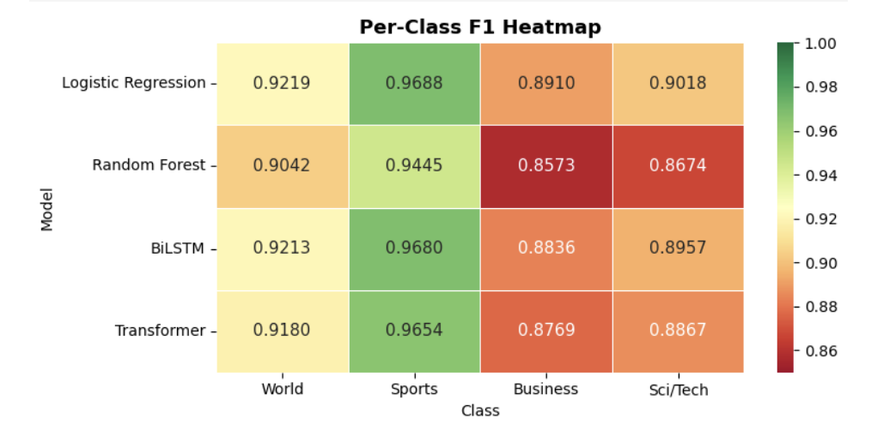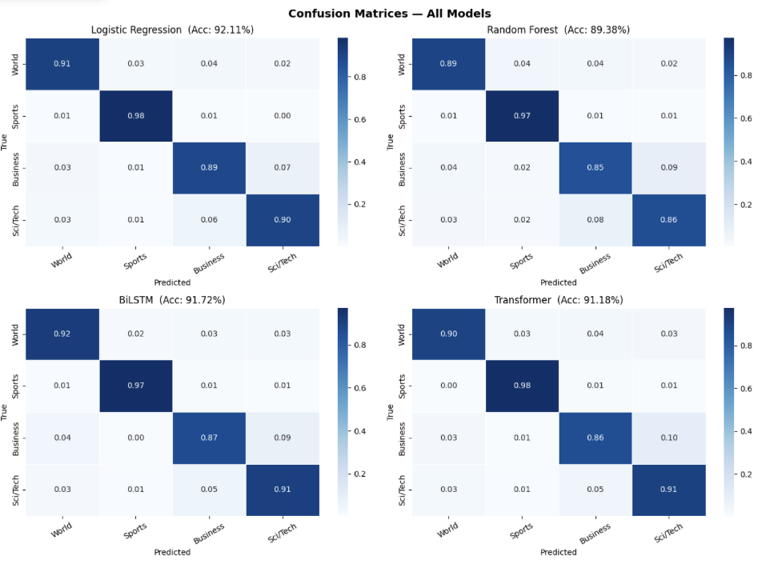
- Question how AI arrived at outputs, even when they appear correct.
I realized the classical models preformed better because of two reasons: a.) the data is simple, its short text with several key words that the model needs to recognize, and therefore – the simpler, classical models were more accurate as this kind of classification does not require much deep learning/complex architectures.
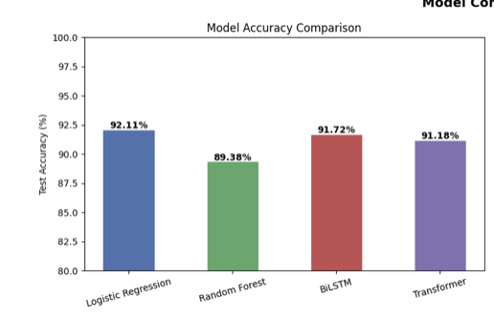
- Cross-validate AI results with domain expertise or external sources.
I used the accuracy and f1 results and compared them to benchmark against the Zhang(2015) TF-IDF baseline of 92.36%, BERT/RoBERT baseline of 94-95%, and Joulin(2016) FastText Baseline of 92.5%.

- Document limitations and hallucinations and how you addressed them.
One limitation was the mix of labels between Business and Science/Technology, since they have a lot of overlap, and it is a large part as to why the models didn’t reach the max accuracy. 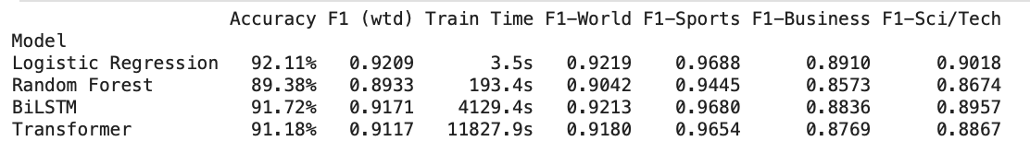
- Use LLMs as a copilot (e.g., generating code, summarizing research,
brainstorming).
Used ChatGPT to help debug model implementations and clarify concepts such as self-attention is Transformers and LSTM gating mechanisms.

- Apply prompt engineering techniques (role prompting, step-by-step, constraints).
Asked questions such as, “Explain why Transformers may underperform BiLSTMs on short text classification” and “compare TF-IDF Logistic Regression vs neural models”.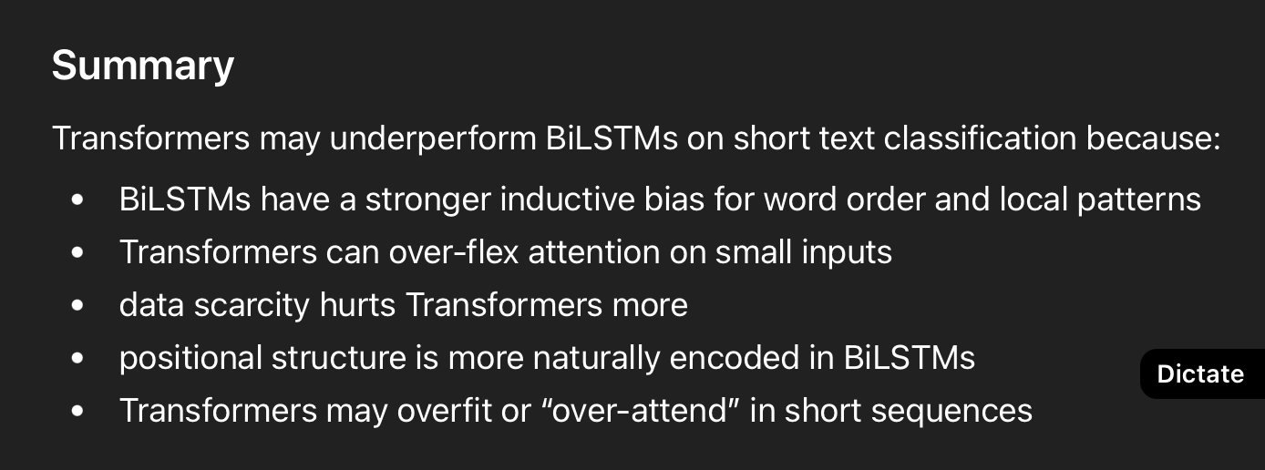
- Generate visuals or outputs with AI to complement your project (charts, simple
images, summaries).
Generated confusion matrices, training/validation loss curves, and F1 score heatmaps. [Screenshots shown already]
- Model selection and evaluation: Compare different AI models (reasoning models,
smaller/faster models, open vs. closed-source) and analyze trade-offs.
Compared Logistic Regression, Random Forest, BiLSTM, and Transformer models. [Screenshots shown]
- Human-in-the-loop validation: Apply your domain expertise to systematically
validate AI outputs
I realized after looking at the confusion matrices that the misclassification within the Business and Science/Technology categories was due to the overlap in the topics(which is a limitation with the dataset itself).
10.) Compare outputs from multiple AI tools (e.g., ChatGPT vs. Copilot).
Used ChatGPT and Gemini for model debugging. 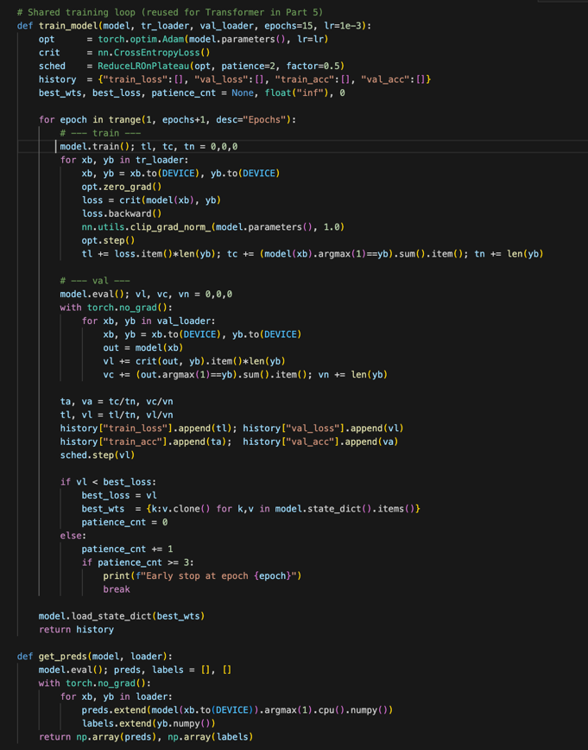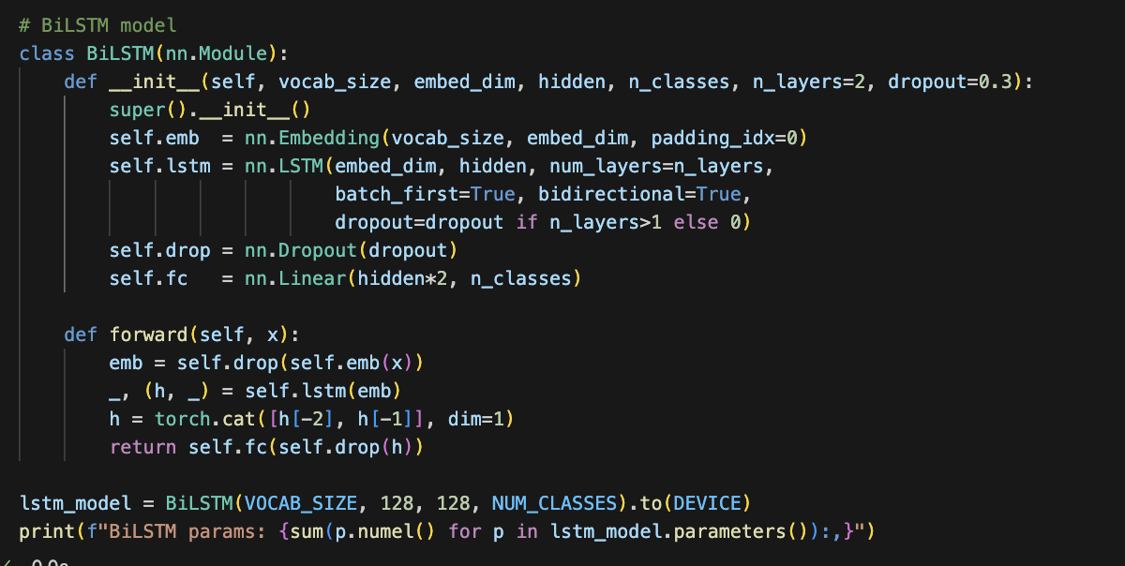
[Examples code blocks where I used Chat to help debug.]
---

Findings
What did you learn, discover, or build as part of this project? How effective were your approaches? Include any outputs that help demonstrate your findings.
You can further explore topics related to evaluation, limitations, and critical analysis in this section as well.
✍️ Logistic Regression preformed the best, most likely because it was a classical model being used on simple data, and the Random Forest, Transformer, and BiLSTM were more complex and did not need to be applied to a dataset like mine. This was the dataset(https://huggingface.co/datasets/wangrongsheng/ag_news). Also, models were mixing up labels for Business and Science/Technology due to the overlap of certain words within the dataset itself.
---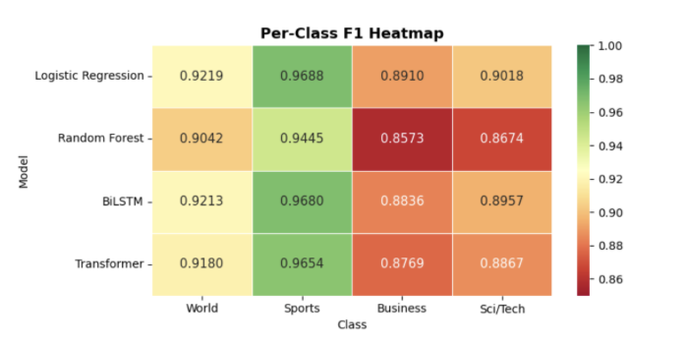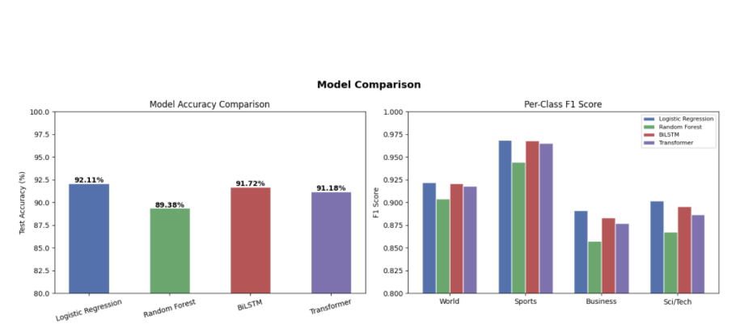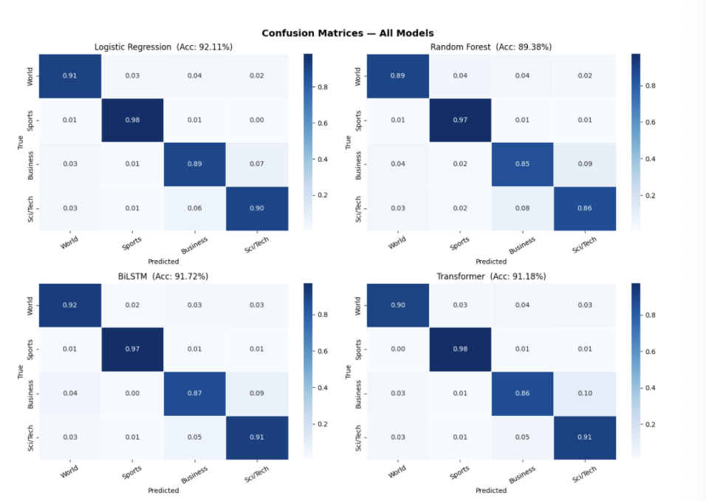

Assignment Memo and Reflection
Write a short memo reflecting on your experience:
- Why did you pick this project?
- How has this helped you revisit or refine skills from the class?
- How did AI support (or challenge) your work?
- What are your key takeaways about AI, business information systems, or your own learning?
- How might you apply these insights beyond this course?
✍️ I feel like I was able to apply data skills through this project. I chose this project because it's a well-known project for natural language processing. I applied feature engineering, supervised learning, and model evaluation. I gained a deeper understanding of how the TF-IDF is used in practice and why logistic regression can perform better than more complicated models on simple text classification data. I also applied evaluation metrics such as accuracy, F1 score, and confusion matrices to make meaningful comparisons be between the models. I used AI to help debug and refine some of my code as well as explain certain concepts or feature engineering related terms that helped me strengthen my models. One main take away from this project is that the model performance depends a lot on the data itself, not just how complex the is. Beyond this course I can apply these data science skills to real life since I want to be a data scientist, exploratory data analysis, model evaluation, and model comparison will be a large part of my work.

---

Organization and Formatting
Confirm here that you have organized your report according to the provided template, ensured clarity and readability, and proofread your document.
✍️ Confirm here
---
Submission Checklist:
- ☐ All sections are completed as per the project guidelines.
- ☐ 📷 Screenshots and evidence are included where necessary.
- ☐ The document is proofread and formatted correctly.
- ☐ All guidelines and rubric criteria are met.
---

Appendix – Example AI Skills
Here are some examples of skills you might apply in your project. You are not limited to these, but they can help you brainstorm:
Critical Evaluation Skills (Core Requirements):
- Evaluate and critique AI outputs for accuracy, reliability, and correctness.
- Question how AI arrived at outputs, even when they appear correct.
- Cross-validate AI results with domain expertise or external sources.
- Document limitations and hallucinations and how you addressed them.
Foundational AI Skills:
- Create structured prompt workflows (chaining prompts to build on each other).
- Use LLMs as a copilot (e.g., generating code, summarizing research, brainstorming).
- Apply prompt engineering techniques (role prompting, step-by-step, constraints).
- Incorporate AI results into another tool (e.g., export data to Excel or Docs).
- Compare outputs from multiple AI tools (e.g., ChatGPT vs. Copilot).
- Experiment with multimodal inputs (text + image or text + audio).
- Generate visuals or outputs with AI to complement your project (charts, simple images, summaries).
Advanced AI Skills:
- Model selection and evaluation: Compare different AI models (reasoning models, smaller/faster models, open vs. closed-source) and analyze trade-offs.
- Retrieval-Augmented Generation (RAG): Incorporate external data/documents into your prompts to ground AI outputs and reduce hallucinations.
- Hosting your own LLM (optional/advanced): Set up a local or cloud-hosted LLM on a GPU (e.g., using Ollama, LM Studio, or Hugging Face models) and test it against hosted models.
- Human-in-the-loop validation: Apply your domain expertise to systematically validate AI outputs.
---

